**To:** Prof. Jie Yang, EE-286 Section 1

**From:** Team 5, EE-286 Section 1

Evan Genuise, Mason Gerace, William McGerty, Aidan Nash, and Joshua Pollock

**Date:** October 18, 2018

**Subject:** Project 2: Update Memo 2

**Introduction:**

In this memo, we will be going over what the team has accomplished so far with our project. We created a new updated WBS and Gantt Chart for this memo. Each will reflect the changes to the project and our decision of the circuit design.

**Progress:**

Our group has now completed both the design and building stages of our project. We have only a few steps left before the project is complete. Currently our group is troubleshooting our design and optimizing it the best of our abilities. After this, our group will be prepared for the presentation to come next Tuesday or Thursday.

**Updated Gantt Chart:**

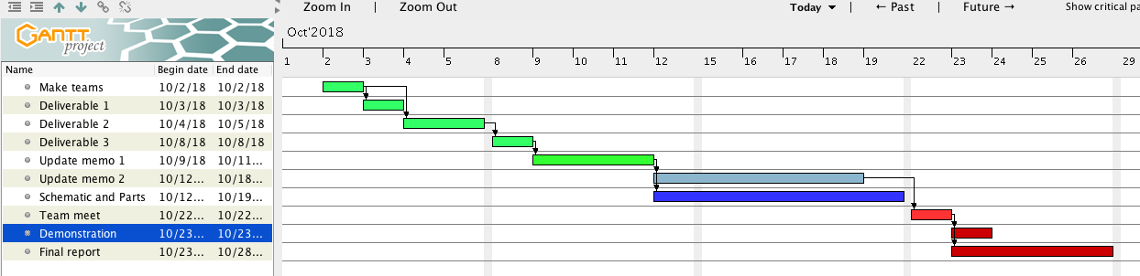

Here we have our updated Gantt chart. We changed some of the due dates, as well as changed the colors that correlate to assignments. Green means completed, blue means in progress, and red is the color of importance. With an updated Gantt chart we will be able to plan the project out in a more efficient manner.

**Updated WBS:**

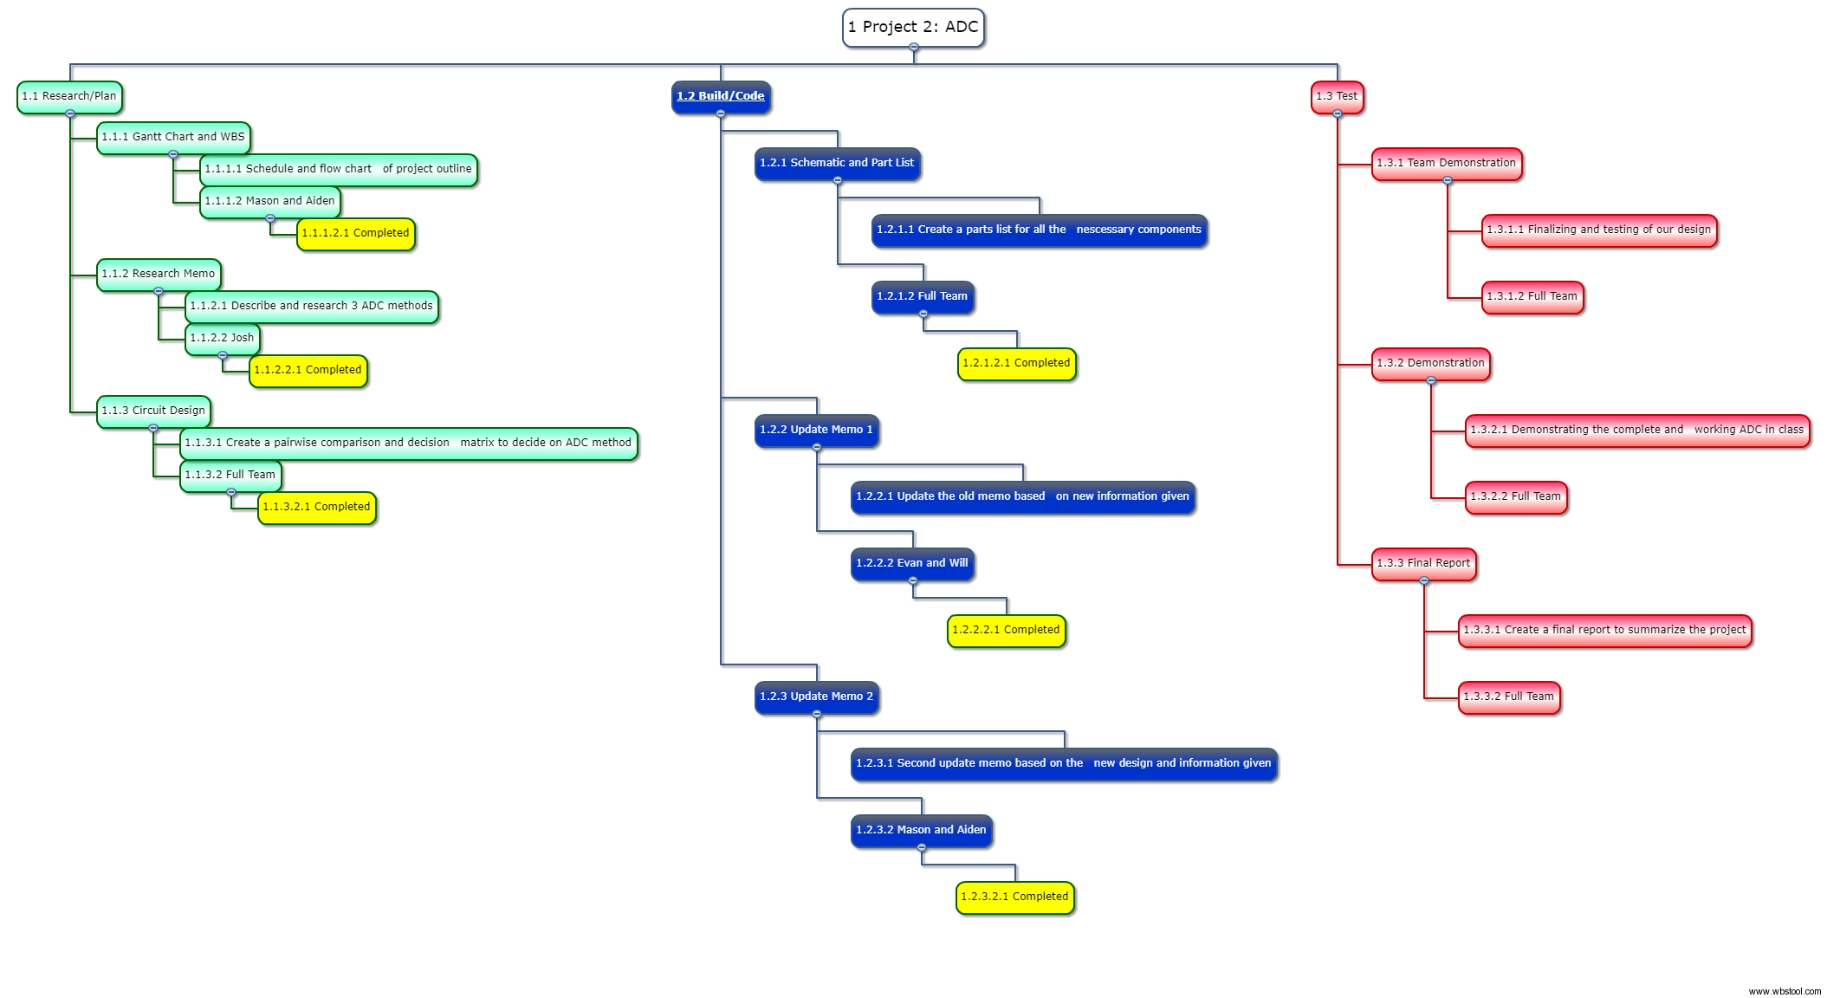

With an updated WBS chart we are able to keep track of what has been completed and what still needs to be worked on. In the chart we can see the completed items in the research/plan branch marked in yellow. Our next step prepare the design for in-class presentation.

**Conclusion:**

With an updated WBS and Gantt chart, our team has a clear and concise timeline of our duties and outline of the project due dates. With our flash converter ADC now designed and assembled, our group is troubleshooting and optimizing the design before our presentation.

**Attachments:** None